

22f-3104

Database Lab 7



March 15, 2024

fast cfd campus

**Basic Queries:**

1. **Write a simple SQL query to retrieve all columns from a table named "DEPT".**

**Code:** SELECT * from Dept;

**Screen Shot:**

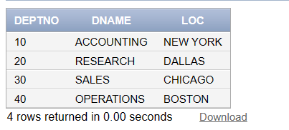

1. **Write a SQL query to select only the "ENAME" and "JOB" columns from the "EMP" table.**

**Code:** SELECT ENAME, JOB FROM EMP;

**Screen Shot:**

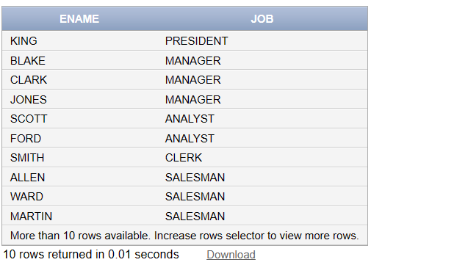

1. Write a SQL query to retrieve employees whose job is either "MANAGER" or "ANALYST" using the IN operator.

**Code:** SELECT * from EMP where JOB IN('MANAGER','ANALYST');

**Screen Shot:**

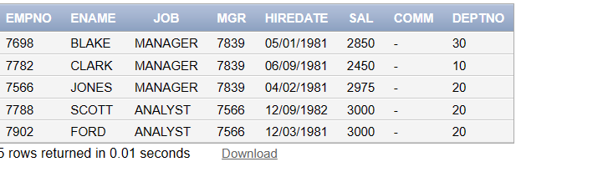

1. Write a SQL query to retrieve employees hired between 12/17/1980, and 09/28/1981, using the BETWEEN operator.

**Code:** SELECT * from EMP where HIREDATE Between '12/17/1980' AND '09/28/1981';

**Screen Shot:**

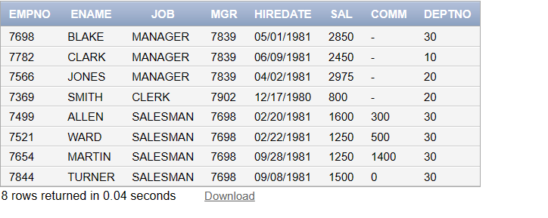

1. Write a SQL query to retrieve employees whose names start with the letter "S" using the LIKE operator.

**Code**: SELECT * From EMP Where ENAME LIKE 'S%'

**Screen Shot:**

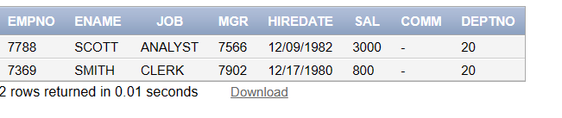

1. Write a SQL query to retrieve employees who do not have a manager (i.e., the "MGR" is NULL) using the IS NULL operator.

**Code:** SELECT * FROM EMP where MGR IS NULL;

**Screen Shot:**

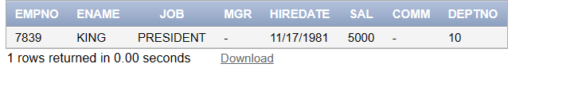

1. Write a SQL query that combines multiple operators (e.g., SELECT, WHERE, AND, OR) to retrieve employees who meet specific criteria. For example, retrieve employees in the department no. 20 hired between 1980 and 1982.

**Code:** SELECT * From EMP where DEPTNO=20 AND HIREDATE Between '01/01/1980' AND '12/31/1982';

**Screen Shot:**

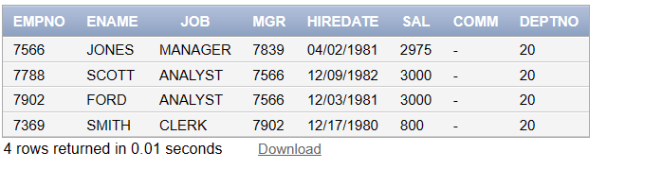

1. Write a SQL query to retrieve a list of unique locations names from an "DEPT" table using the DISTINCT clause.

**Code:** SELECT DISTINCT LOC FROM DEPT;

**Screen Shot:**

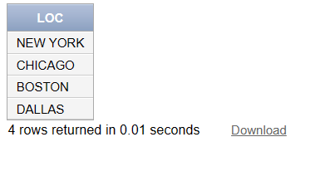

1. Write a SQL query to display the salary of employees after incrementing current salary 10%, as updated salary.

**Code:** SELECT ENAME, SAL * 1.1 AS "UPDATED SALARY" FROM EMP;

**Screen Shot:**

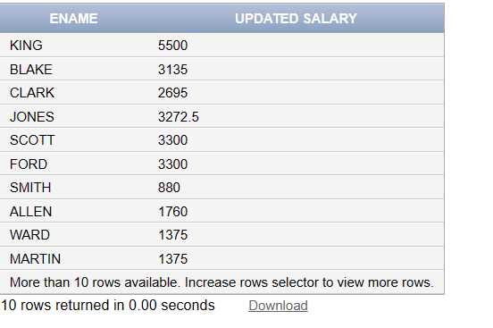

**Functions**

1. **Add 4 records in EMP and 4 records in DEPT table appropriately. Note: Insert two tuples with column list and other two without column list method.**

**Code:**

**Task 1:**

Department:

INSERT INTO DEPT (DEPTNO,DNAME,LOC) VALUES (1,'HR','Jauharabad');

INSERT INTO DEPT (DEPTNO,DNAME,LOC) VALUES (2,'CS','Sargodha');

INSERT INTO DEPT (DEPTNO,DNAME,LOC) VALUES (3,'SE','Khushab');

INSERT INTO DEPT (DEPTNO,DNAME,LOC) VALUES (4,'AI','Abdul Hakim');

SELECT * From DEPT

EMPLOYEE:

-- Inserting data into the EMP table

INSERT INTO EMP (EMPNO, ENAME, JOB, MGR, HIREDATE, SAL, COMM, DEPTNO) VALUES (1001, 'Hamza', 'General', 4213, '11/03/2002', 12000, NULL, NULL);

INSERT INTO EMP (EMPNO, ENAME, JOB, MGR, HIREDATE, SAL, COMM, DEPTNO) VALUES (1002, 'Hammad', 'HOD', 4231,'07/03/2002', NULL, NULL, NULL);

INSERT INTO EMP (EMPNO, ENAME, JOB, MGR, HIREDATE, SAL, COMM, DEPTNO) VALUES (1003, 'Nadeem', 'Lecturer', 4562, '10/03/2002', NULL, NULL, NULL);

INSERT INTO EMP (EMPNO, ENAME, JOB, MGR, HIREDATE, SAL, COMM, DEPTNO) VALUES (1004, 'Qasim', 'Instructor', 4231,'04/03/2002', NULL, NULL, NULL);

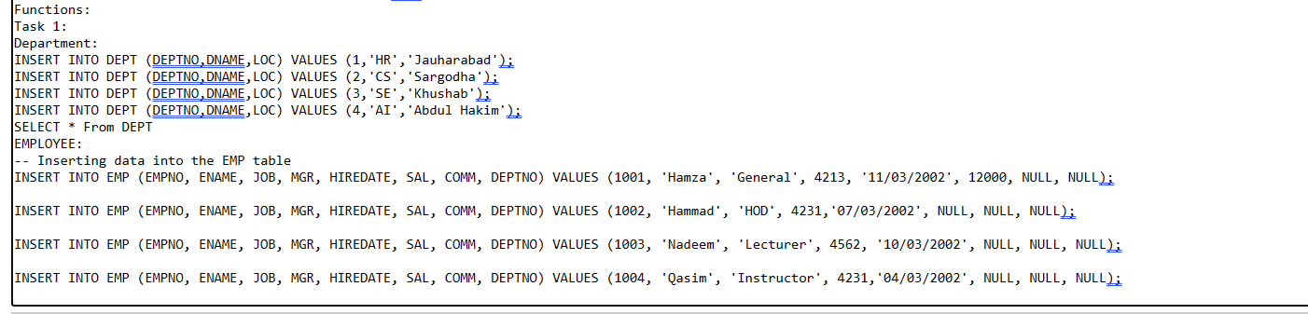

**Screen Shot:**

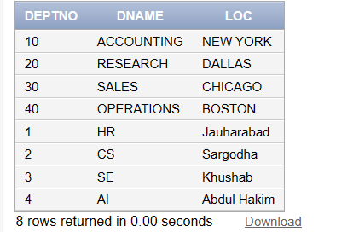

1. **Write SQL query to Output max salary grouped by dept no.**

**Code:** SELECT DEPTNO, MAX(SAL) AS MAX_SALARY FROM EMP GROUP BY DEPTNO;

**Screen Shot:**

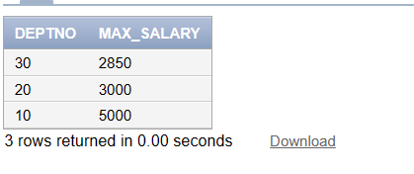

1. **Write SQL query to Output dept no. whose average salary is greater than 1k.**

**Code:**

**Screen Shot:** SELECT DEPTNO FROM EMP GROUP BY DEPTNO HAVING AVG(SAL) > 1000;

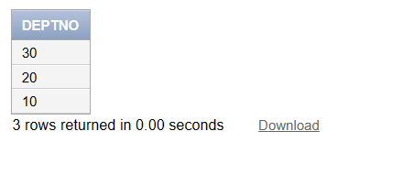

1. **Write an SQL query that will sort with respect to hire date (descending) and return all records of employee.**

**Code:** SELECT * FROM EMP ORDER BY HIREDATE DESC;

**Screen Shot:**

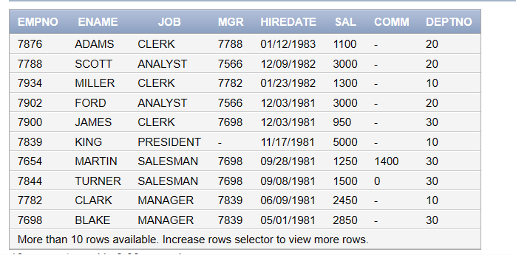

1. **Update any employee name as your “name”.**

**Code:** UPDATE EMP SET ENAME = 'Manan' WHERE EMPNO = 7839;

SELECT * from EMP;

**Screen Shot:**

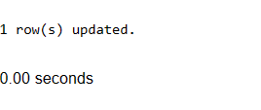

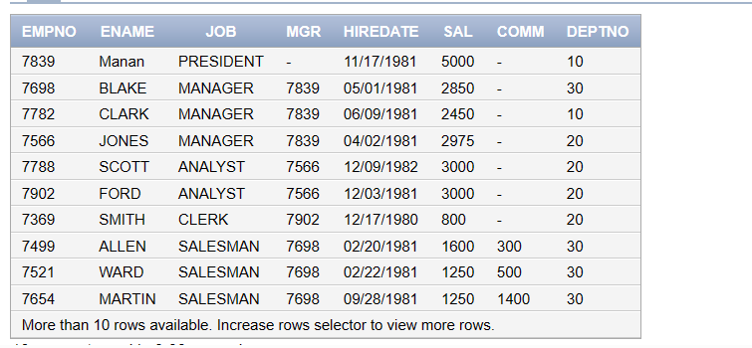

1. **Write a SQL query to retrieve a list of all departments along with the total number of employees in each department.**

**Code:** SELECT DEPTNO, COUNT(*) AS TOTAL_EMPLOYEES FROM EMP GROUP BY DEPTNO;

**Screen Shot:**

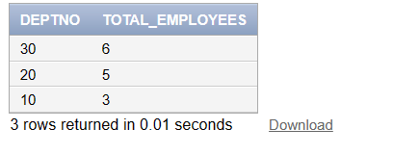

1. **Write a SQL query to retrieve the average salary of employees in each department. Use the GROUP BY clause to group data by department.**

**Code:** SELECT DEPTNO, AVG(SAL) AS AVERAGE_SALARY FROM EMP GROUP BY DEPTNO;

**Screen Shot:**

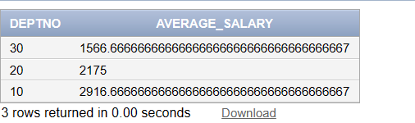

1. **Write a SQL query to retrieve employees who work in departments with an average salary greater than 3,000. Use a nested select query to find the average salary for each department and filter the results accordingly.**

**Code:** SELECT * FROM EMP WHERE DEPTNO IN (SELECT DEPTNO FROM EMP GROUP BY DEPTNO HAVING AVG(SAL) > 3000);

**Screen Shot:**

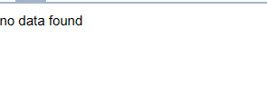

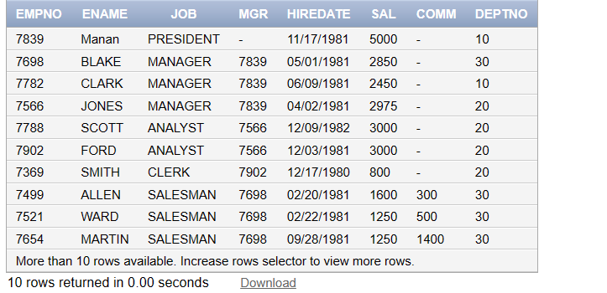

1. **Write a SQL query to delete a specific department from the "DEPT" table.**

**Code:** DELETE FROM DEPT WHERE DEPTNO = 1;

SELECT * from DEPT

**Screen Shot:**

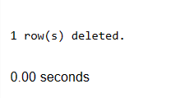

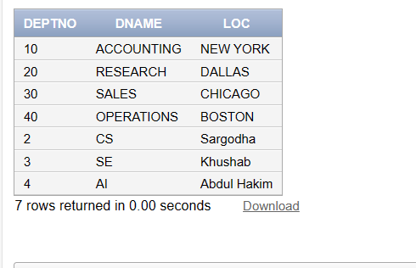

Sub - Query

1. **Write a SQL query to retrieve employees who have a salary greater than 2850 using the EXISTS operator.**

**Code:** SELECT * FROM EMP e WHERE EXISTS (SELECT * FROM EMP WHERE SAL > 2850 AND e.EMPNO = EMP.EMPNO);

**Screen Shot:**

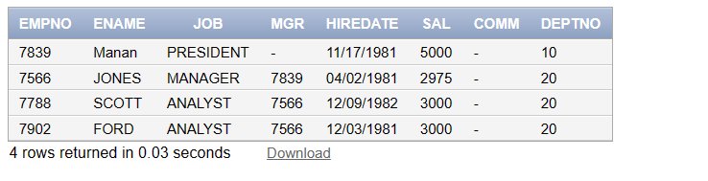

1. **Write a SQL query to retrieve employees who do not have a salary greater than 1600 using the NOT EXISTS operator.**

**Code:** SELECT * FROM EMP e WHERE NOT EXISTS (SELECT * FROM EMP WHERE SAL > 1600 AND e.EMPNO = EMP.EMPNO);

**Screen Shot:**

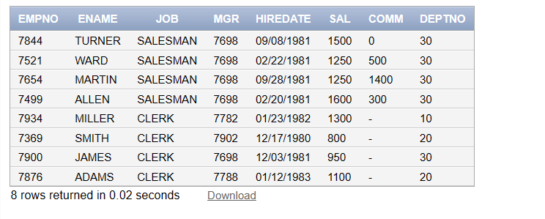

1. **Display the employee who got the maximum salary.**

**Code:** SELECT * FROM EMP WHERE SAL = (SELECT MAX(SAL) FROM EMP);

**Screen Shot:**

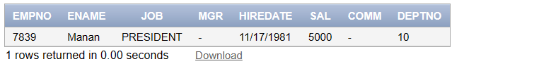

**Display the employees who are working in Sales department.**

**Code:**

SELECT * FROM EMP WHERE DEPTNO IN (SELECT DEPTNO FROM DEPT WHERE DNAME = 'SALES');

**Screen Shot:**

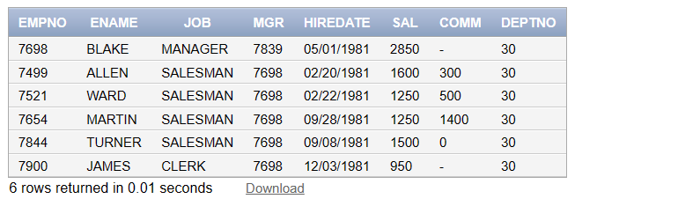

1. **Display the employees who are working in Sales department.**

**Code:**

**Screen Shot:**

**Display the employees who are working in “New York”**

**Code:** SELECT * FROM DEPT WHERE DEPTNO IN (SELECT DEPTNO FROM DEPT WHERE LOC = 'NEW YORK');

**Screen Shot:**

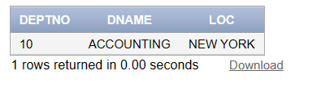

1. **Find out no. of employees working in “Sales” department.**

**Code:** SELECT COUNT(*) AS NUM_EMPLOYEES_IN_SALES FROM EMP WHERE DEPTNO = (SELECT DEPTNO FROM DEPT WHERE DNAME = 'SALES');

**Screen Shot:**

